**Assignment 2 – Static & Dynamic Analysis**

1. To perform static analysis of the code, forward manual slicing was used. Using this method, a variable X, was chosen and all statements involving, or utilizing X are sliced from the program. To perform this a python file was used to read the python code as a text file line by line. For each line it is parsed to look for the specific variable name being sliced. The variable name is passed as a command line argument to the when the program is running from the terminal.

***Figure 1: Code used to perform static analysis.***

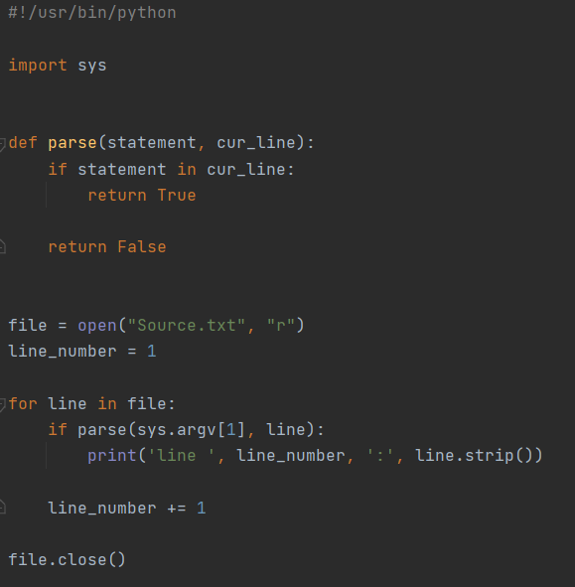

The code reads the text file line by line, and calls parse() function using the current line of the file, as well as the variable name the slicing is according to. If the variable name is found in that line the line is then printed to the terminal, along with the line number.

***Figure 2: Static analysis for snack_x variable.***

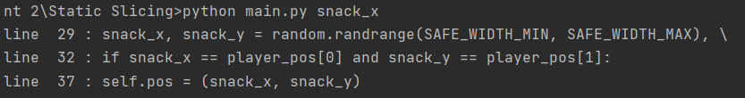

***Figure 3: Static analysis for Snake object.***

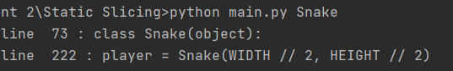

***Figure 4: Static analysis for screen variable.***

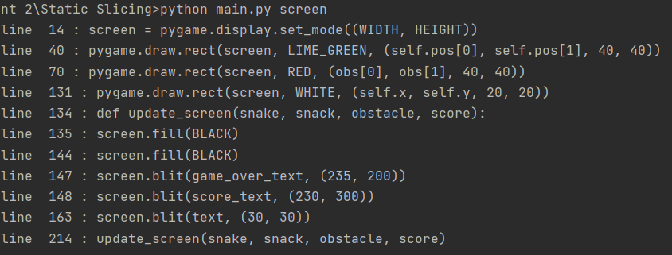

***Figure 5: Static analysis for clock variable.***

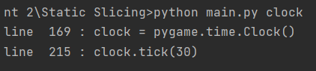

***Figure 6: Static analysis for HEIGHT variable.***

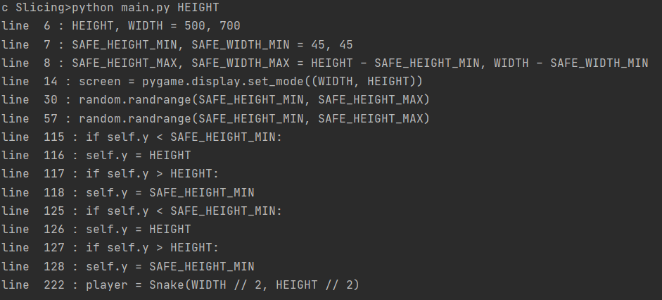

**b.)** In order to perform dynamic analysis on the code an instrumentation method was used on the source code. With this method measurements probes such as time modules are used to examine how the code operates at runtime. To perform this the timeit module was used to keep record of time spent per method call. Along with the module, multiple lists were initialized to keep track and organize the information. After the game is finished executing all data collected from the analysis is outputted via console.

***Figure 7: List for holding data collected from instrumentation.***

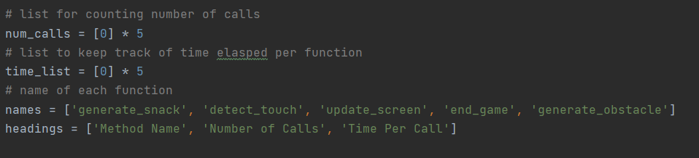

***Figure 8: Code to count number of calls and start the timer to for the function call.***

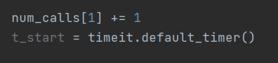

***Figure 9: Code to end timer and update the amount of time taken by that specific method.***

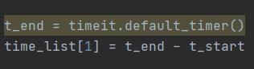

***Figure 10: Code to output data collected from analysis.***

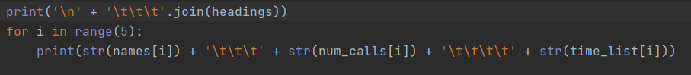

***Figure 11: Output from analysis***

